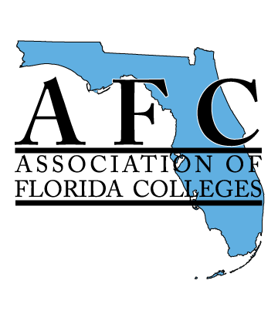 | 5.10 Learning Resources Commission Board Report  Reporting Dates: March 23 – June 26, 2018  Submitted by Claire A. Miller, Chair  millerc@southflorida.edu | 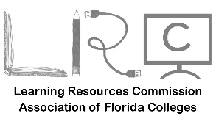
Activities
- Based on feedback from LRC members, we offered a free conference registration to facilitate the ability of LRC members to attend the Region IV conference.
- Members of LRC served as volunteers at Region IV conference for set-up and breakdown.

Fundraisers
- Funds from Region IV Conference were deposited in AFC LRC account

Conferences
- Region IV, LRC, and IEPPD Conference was held at South Florida State College on Friday, April 27
- A (short) LRC meeting was held in person and virtually announcing Exemplary Practice winners and thanking sponsors.
- LRC members sponsored four sessions at conference:

- Radically Redesigning the Library Curriculum: Kevin Arms @ 10 AM
- Creating a Culture of C.A.R.E.: Chris Teumer @ 10 AM
- Programming for Student Veterans: A Book Discussion Group: Brett Williams @ 11 AM
- Get on Top of To-Do’s: Finding a Planning Solution for You: Claire A. Miller @ 2:20 PM

Executive Board Summary
- Beryl White-Bing from St. Johns River State College serves as Vice Chair.
- Brett Williams from Indian River State College serves as our Secretary and Webmaster
- Claire A. Miller, Chair met with Region IV planning committee on March 20 and April 10 to confirm details and assist in preparations.
- Chair Miller attended AFC Board Meeting on April 3 in Orlando.
Membership: 573

Financial Report
Starting Balance: $2499.28
Payment for Plaque Reimbursement to Kendra Auberry (03/07/2018): -100.00
Check from Region IV Conference (06/21/2018): +437.50
End Balance: $2836.78

